# CS 255 System Design Document

## UML Diagrams

### UML Use Case Diagram

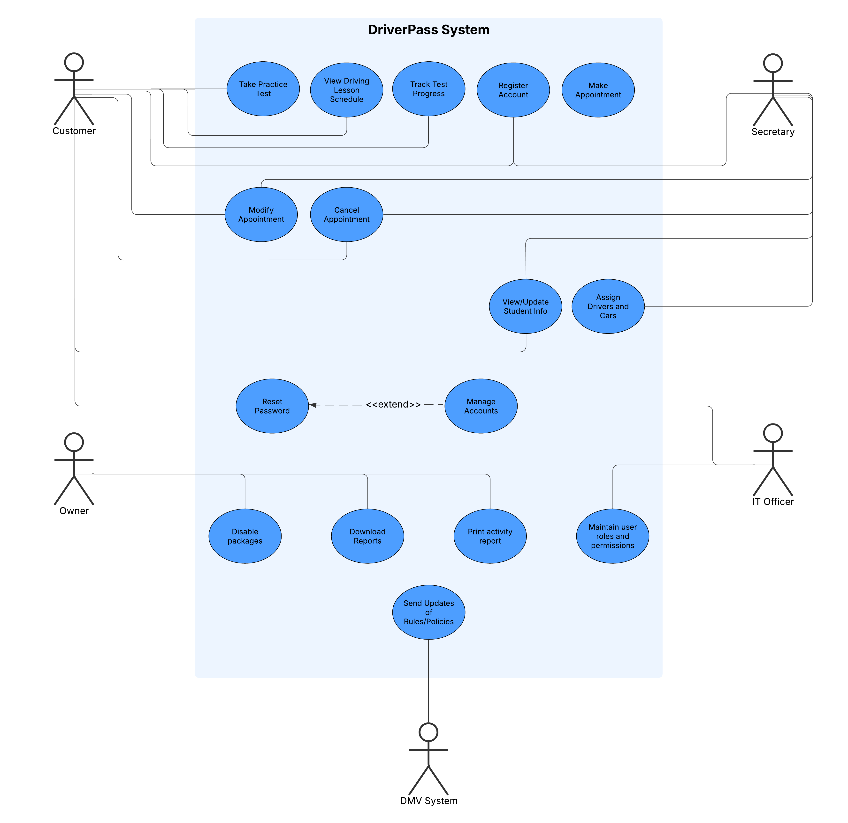

### UML Activity Diagrams

**Use Case: Customer scheduling an appointment for a practice test**

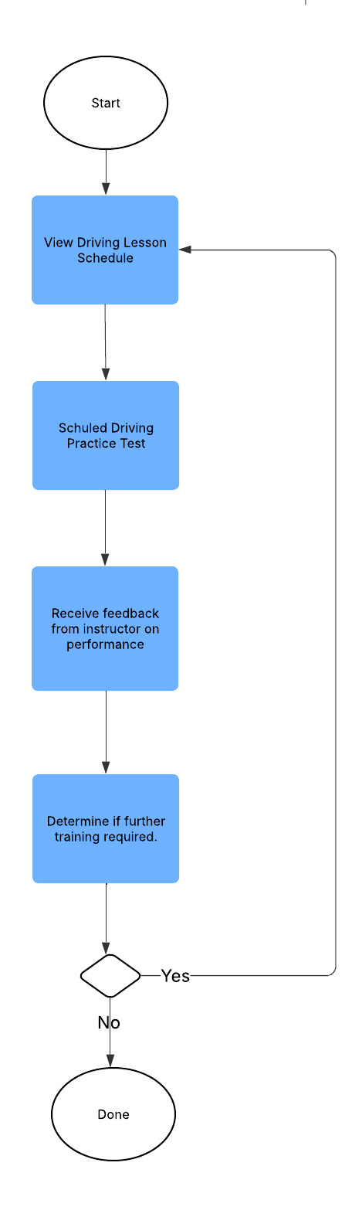

**Use Case: Customer Registering Account and Viewing Content**

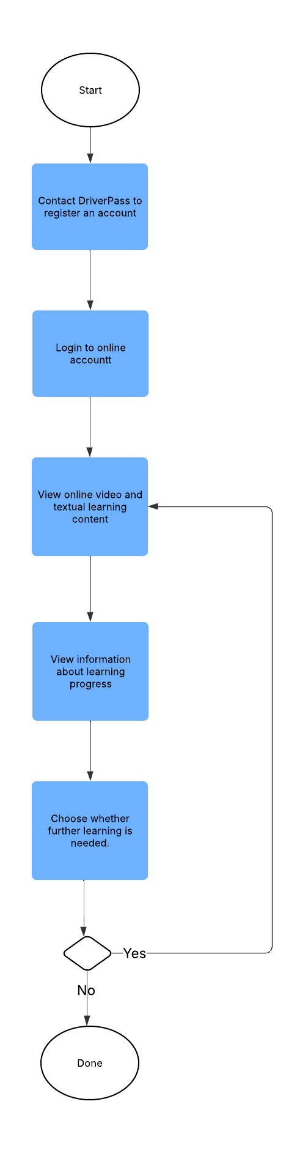

### UML Sequence Diagram

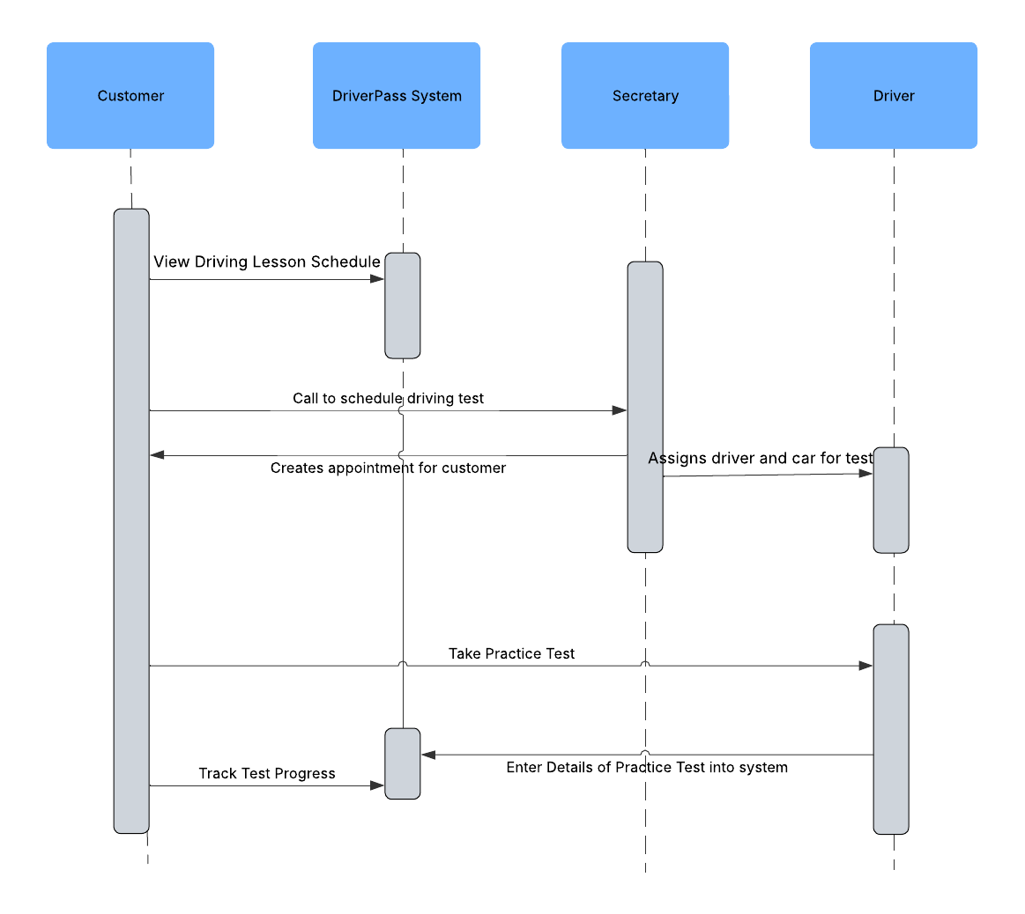

### UML Class Diagram

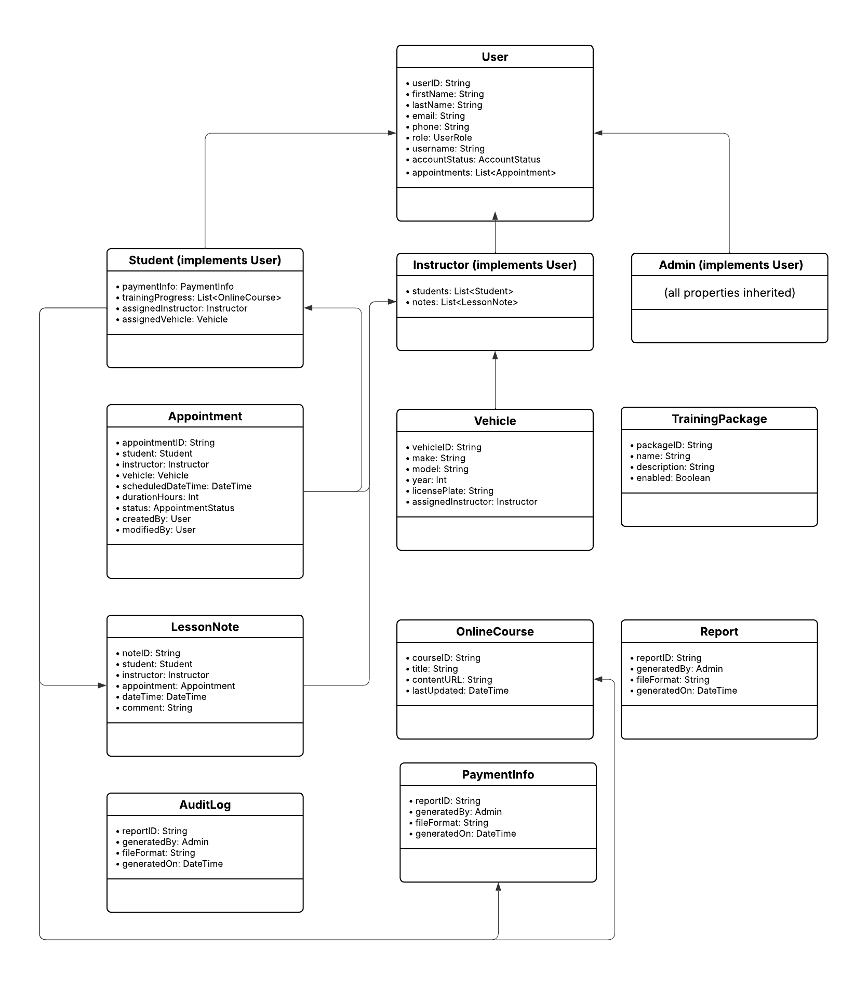

## Technical Requirements

#### Hardware Requirements

* Cloud Hosting Infrastructure (e.g., AWS, Azure, Google Cloud Platform
* User Devices:
  + Student, secretary, and instructor access via:
    - Desktop or laptop with internet browser
    - Smartphone or tablet with mobile browser
* Backup Storage:
  + Cloud-based storage bucket or snapshot service for daily automated backups

#### Software Requirements

* Operating System (Cloud server):
  + Ubuntu Server or similar Linux distribution
* Web Server:
  + Nginx or Apache HTTP Server
* Application Platform:
  + Backend: Node.js, Python (Django/Flask), or Java (Spring Boot)
  + Frontend: React.js, Angular, or Vue.js
* Database:
  + PostgreSQL or MySQL (Relational DB with role-based access)
* Authentication:
  + OAuth 2.0 with multi-step login support
  + Encrypted password and security question management
* Encryption:
  + HTTPS (TLS) for all data transmission
* 3rd-Party Integrations:
  + Secure credit card processor (e.g., Stripe, Square)
  + DMV content feed

#### **Development Tools**

* Version Control:
  + Git with GitHub/GitLab/Bitbucket
* IDE:
  + VS Code, IntelliJ, or PyCharm
* CI/CD Pipeline:
  + GitHub Actions, GitLab CI, or Jenkins
* Project Management:
  + Jira or Trello
* Testing Frameworks:
  + Jest (frontend), PyTest/JUnit (backend)
* Security Tools:
  + OWASP Dependency Check or similar tools

#### **Infrastructure Requirements**

* Cloud Platform Services:
  + Compute instances for web and backend servers
  + Managed relational database service (e.g., Amazon RDS)
  + Object storage for reports and media (e.g., Amazon S3)
  + Load balancer and auto-scaling for high availability
* Monitoring and Logging:
  + CloudWatch, ELK stack (Elasticsearch, Logstash, Kibana), or Datadog
* Backup and Recovery:
  + Automated daily snapshots of database and filesystem
  + Versioning and retention policy for backups
* Audit Logging System:
  + Centralized log collector with timestamped user actions